Assignment 1

NED University of Engineering & Technology

Course: Data Structure & Algorithms (Th)

Course code: CT-493

Instructor: Dr. Muhammad Mubashir Khan

Department: BCIT (Second Semester)

Name: Muhammad Shaheer Akram

Roll No: CT-17055

**Question # 1**

In C language each variable is associated with a basic data type example **char, int, float** and **double**. Each data type occupies some specific number of bytes in the memory stack example: char is of 1 byte and int is of 4 bytes. So, whenever we declare a variable of int data type we reserve 4 bytes of area in memory for that variable so, whatever data we store in that variable it will be stored in that area in binary form.

Hence it is very important to mention data type of a variable because, compiler should understand how much amount of area it have to reserve in the memory stack for storing binary data in memory.

Since C follows static typing we cannot declare a variable without specifying its data type. Some languages like Java Script, PHP, Python follow dynamic typing, so we do not have to mention data type for the binary data stored in the memory.

**Question # 2**

**Primitive data types**

The basic data types provided by the programing language are called primitive data types in C language there are four basic arithmetic type specifiers or primitive data types i.e. are int, char, float and double.

**Int**

Int or integer data type in C have a size of 4 bytes it can hold only integer type of ranging values between -2,147483,684 to 2,147,483,647.

The int data type supports modifiers like signed, unsigned, short and long.

**Short**

The short int have size 2 bytes and have range starting from -32,768 and ends at 32,767.

**Long**

The long int have size of 4 bytes and have range between -2,147,483,648 to 2,147,483,647

**Signed**

The signed int act same for short and long int, the most significant bit in signed int is used to represent the sign of the digit, it have the same size and range as int variable.

**Unsigned**

The unsigned int contains only positive values for every short and long unsigned int, in unsigned int the most significant bit is also used in representing the value hence, it have a larger range despite having the same size as of short and long int. the unsigned short int have range between 0 to 65,535 and unsigned long int have range starts from 0 and ends at 4,294,967,295.

**Example**

#include<stdio.h>

int main()

{

int x=-2548;

unsigned int y=654;

short int z=-596;

unsigned short int p=548;

long int q=-654644;

unsigned long int r=665465465;

signed int s=-5458;

printf("%d\n %d\n %d\n %d\n %d\n %d\n %d",x,y,z,p,q,r,s);

}

The output is

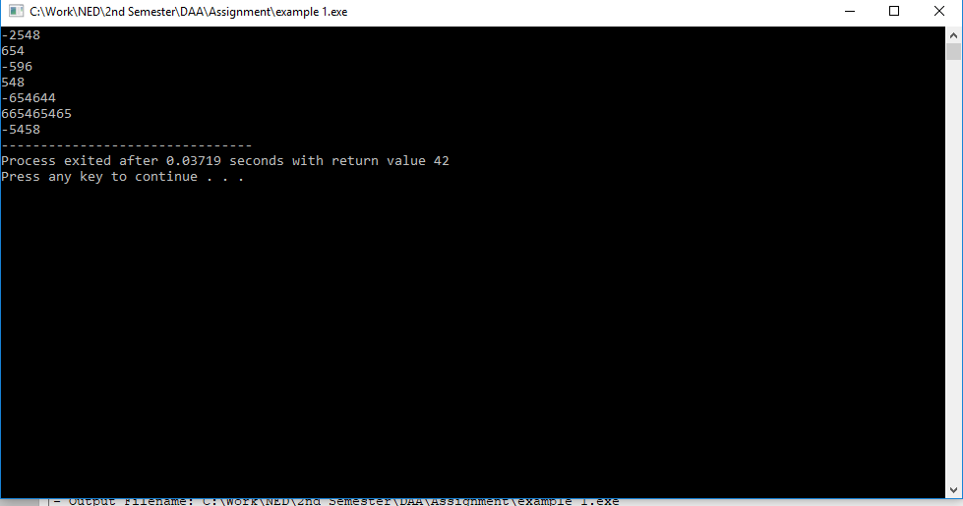

**Char**

Char or character data type have a size of 1 byte it hold integer type values and convert them to characters using ascii table, char hold values between -128 to 127

It supports signed and unsigned modifiers. The signed char have range between -128 to 127 and unsigned char have values between 0 to 255.

**Example**

#include<stdio.h>

int main()

{

unsigned char x='A';

printf("%d %c",x,x);

}

Output

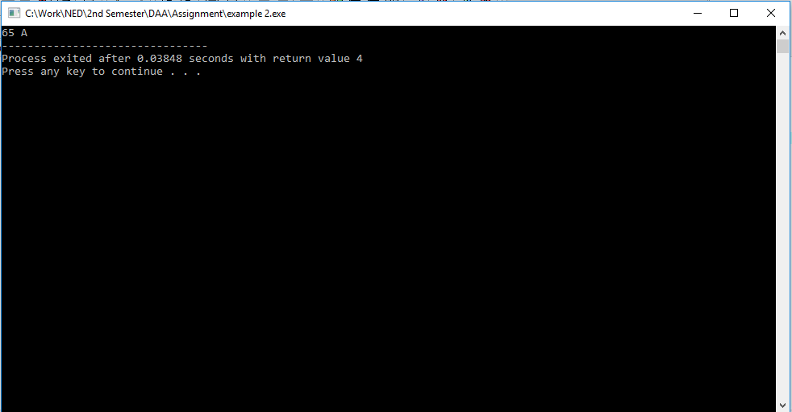

**Float and Double**

The float type variable store values with a floating point such as 176.2548, 48.456 etc. they have a storage size of 4 bytes and have range between 1.2*10^-38 to 3.4*10^+38 and it have a precision of 6 decimal places.

The double type variable have double precision of 15 decimal places its size is 8 bytes and it have a range between 2.3*10^-308 to 1.7*10^308.

The long double have precision of 19 decimal places and have storage size of 10 bytes and its value range is 3.4e-4932 to 1.1e4932.

**Example**

#include<stdio.h>

int main()

{

float x=2.465485;

double y=1.1848792;

long double z=1455.5646844644;

printf("%f %lf %lf",x,y,z);

}

Output

